A DL MINI PROJECT REPORT ON

**“Colorizing Old Black & White Images using CNN”**

SUBMITTED TO THE SAVITRIBAI PHULE PUNE UNIVERSITY, PUNE IN THE   
 FULFILLMENT OF THE LPV-DL

FINAL YEAR OF COMPUTER ENGINEERING

SUBMITTED BY

ADVAIT NAIK 41352

KAUSTUBH NETKE 41353

RHEA SHAH 41363



DEPARTMENT OF COMPUTER ENGINEERING PUNE INSTITUTE OF COMPUTER TECHNOLOGY   
 DHANKAWADI, PUNE - 411043

PICT, Department of Computer Engineering 2024-25



SCTR’s PUNE INSTITUTE OF COMPUTER TECHNOLOGY, PUNE   
 DEPARTMENT OF COMPUTER ENGINEERING

2024 -2025

CERTIFICATE

This is to certify that the SPPU Curriculum-based LPV-DL entitled

**Colorizing Old Black & White Images using CNN**

Submitted by

ADVAIT NAIK 41352

KAUSTUBH NETKE 41353

RHEA SHAH 41363

has satisfactorily completed the curriculum-based LPV under the guidance of Prof. Rutuja Kulkarni towards the fulfillment of second year Computer Engineering Semester VIII, Academic Year 2024-25 of Savitribai Phule Pune University

Prof. Rutuja Kulkarni Dr. Geetanjali Kale

Guide Head,

Department of Computer Engineering Department of Computer

Engineering

Place:

Date:

PICT, Department of Computer Engineering 2024-25

ACKNOWLEDGEMENT

It gives us great pleasure in presenting the LPV report on “Colorizing Old Black & White Images using CNN”. First, we would like to take this opportunity to thank our LPV guide Prof.Rutuja Kulkarni for giving us all the help and guidance needed. We are grateful for her kind support and valuable suggestions that proved to be beneficial in the overall completion of this LPV-DL work. We are thankful to our Head of the Computer Engineering Department, Dr. Geetanjali V. Kale, for her indispensable support and suggestions throughout the DBMS project.

NAME OF THE STUDENTS

ADVAIT NAIK

KAUSTUBH NETKE

RHEA SHAH

PICT, Department of Computer Engineering 2024-25

**Title :**

Colorizing Old Black & White Images using CNN.

**Introduction:**

Colour plays a vital role in visual perception and interpretation. However, many historical photographs and early visual media exist only in black and white. With the advancement of deep learning and computer vision, it has become feasible to automatically colorize grayscale images, making them more realistic and visually appealing.

Colourizing black and white images is a challenging task due to the absence of colour information and the need for the model to infer plausible colour representations. Recent developments in deep learning—especially in Convolutional Neural Networks (CNNs)—have enabled models to learn mappings between grayscale and colour image domains with impressive accuracy.

This project focuses on developing a deep learning-based image colourization system that automatically converts black and white images to colour using a pre-trained CNN. Rather than training a model from scratch, we use an existing model trained on a large dataset of colour images. The model predicts the missing AB colour channels given only the L channel (brightness) of an image, using the LAB colour space.

The approach demonstrates the power of transfer learning and the effectiveness of modern CNN architectures in tackling image-to-image translation problems. The project is implemented using Python libraries such as OpenCV, NumPy, and argparse, showcasing how deep learning can be applied to restore and enhance legacy visual content.

**Theory :**

1. **Data Collection:**

* In this project, we do not train a deep learning model from scratch due to the heavy computational and data requirements. Instead, we leverage a pre-trained model trained on a large dataset of colour images. These datasets contain paired grayscale and colour images which help the model learn the mapping from luminance (L) to chrominance (AB) components in the LAB colour space.

1. **Data Preprocessing:**

Before feeding an image to the model, several preprocessing steps are performed:

* Image Resizing: The input image is resized to 224x224 pixels for compatibility with the model input dimensions.
* Normalization: The image pixel values are scaled to a range of [0, 1].
* Colour Space Conversion: The image is converted from BGR (used by OpenCV) to LAB colour space.
* Brightness Centering: The L channel is extracted and adjusted by subtracting 50 to centre the brightness.

1. **Feature Extraction:**

The project uses a **Convolutional Neural Network (CNN)** to predict the AB channels (colour components) from the L channel (brightness). The feature extraction process includes:

* Utilizing layers from the pre-trained model to identify abstract patterns and features in the grayscale image.
* Using cluster centres (from pts_in_hull.npy) that represent quantized colour bins in AB space to guide the prediction.

1. **Model Loading & Prediction:**

The deep learning model used for this task consists of the following components:

* Model architecture defined in colorization_deploy_v2.prototxt.
* Pre-trained weights from colorization_release_v2.caffemodel.
* Colour cluster centers from pts_in_hull.npy.

The model:

* Accepts the L channel input.
* Predict the AB channels.
* Combines the predicted AB with the original L channel to reconstruct the colour image.

1. **Post-processing & Output Generation:**

After prediction:

* The LAB image is re-assembled using the original L and predicted AB channels.
* The image is converted back to the BGR colour space.
* The result is scaled back to 0–255 range and cast to an appropriate image format for visualization.

**Results:**

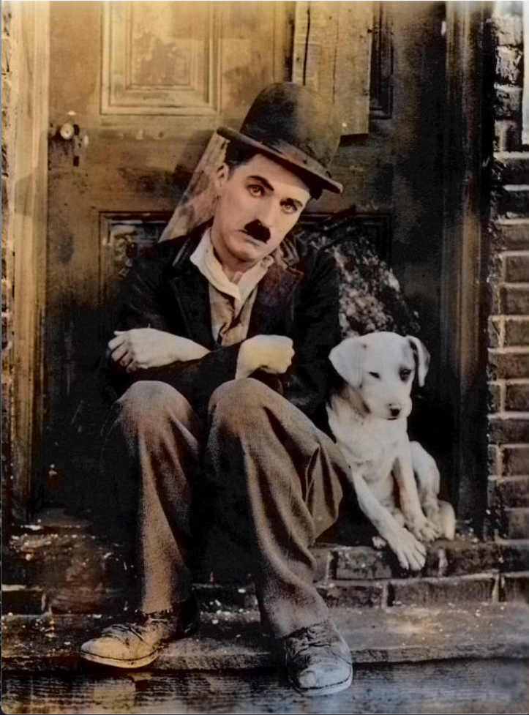

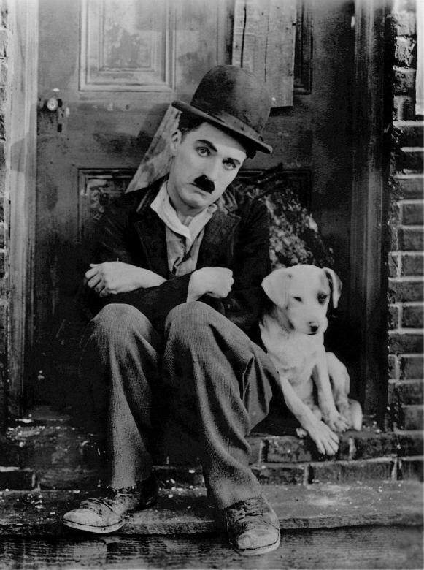

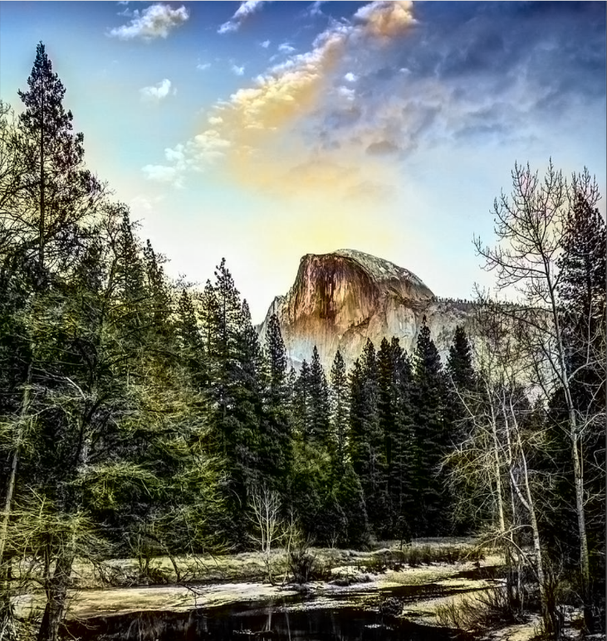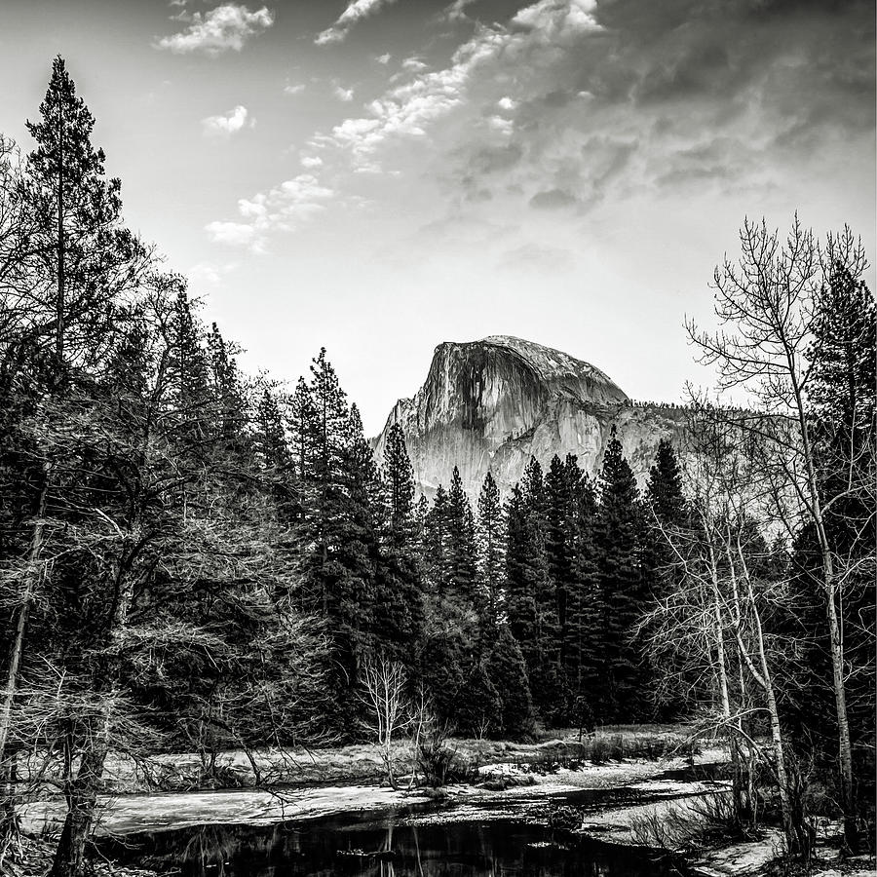

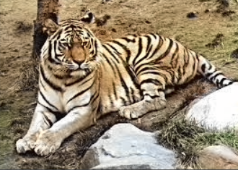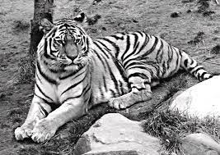**Conclusion:**

In this mini-project, we successfully implemented a deep learning-based system to colourize black-and-white images using a pre-trained Convolutional Neural Network (CNN) model. The project followed a systematic approach comprising model selection, data preprocessing, feature extraction, prediction, and output visualization.

By leveraging a pre-trained model trained on a large-scale dataset, we were able to accurately predict the colour components of grayscale images without the need for extensive training or large computational resources. The use of the LAB colour space allowed the model to focus on predicting colour information (AB channels) while preserving luminance details (L channel).

The final results demonstrate the effectiveness of deep learning in solving complex image-to-image translation problems such as colourization. This project not only enhanced our understanding of CNN-based image processing but also showcased practical applications in fields like historical photo restoration, digital content enhancement, and media production.

Overall, the project highlights the power of modern AI techniques in reviving black-and-white images with realistic colours and provides a strong foundation for future work involving more advanced models like GANs (Generative Adversarial Networks) or self-supervised learning techniques for even higher fidelity results.